

MSc Data Science and MSc Artificial Intelligence Project Handbook

School of Engineering, Computing & Mathematical Sciences



Project Coordinator:

Optimizing Police Deployment with Machine Learning-Based Crime Analysis

Abstract
This research explores machine learning(ML) and deep learning(DL) techniques for crime pattern recognition. It focuses on missing data management in several datasets, including Police Data of UK, demographic, geographic shapefiles, and income data. The research also includes feature encoding and data normalization to enhance model performance. The models experimented upon in this research are Support Vector Machine (SVM), Random Forest (RF), K-Nearest Neighbors (KNN), 1D Recurrent Neural Networks (RNN), and Convolutional Neural Networks (CNN-1D. Out of these, the Random Forest (RF) model was best with reported peak accuracy rate, at 78% and with high F1-scores, particularly for common crime categories. On the contrary, SVM and KNN performed moderately, with accuracy rates of 64%. Deep learning models like CNN-1D and Long Short-Term Memory (LSTM) model performed well but suffered from overfitting, which limited their generalization capability.
Overall, this research highlights the strengths and limitations of different predictive models in crime analysis. It demands further improvement, including the application of stronger regularization methods and the use of a wider variety of data sources. By overcoming these limitations, predictive accuracy can be enhanced, thus making these models more practical and valuable in crime prevention and policy-making.

Table of Contents
Abstract 2
List of Figures 4
List of Tables 5
1 Introduction 1
1.1 Background 1
1.2 Crime Tendencies and Comprehensive Analysis 1
1.3 Data Managment Methods in the Law Enforcement 2
1.4 Problems in Resource Allocation of Forces 3
1.4.1 Limitation of Resources and Financial Plan 3
1.4.2 Developing and Adaptable Crime Trends 3
1.4.3 Revolution in Time and Space 3
1.4.4 Data Integration from Various Sources 3
1.4.5 Evaluating Impact and Effectiveness 4
1.5 The Requirement for Effective Deployment Techniques 4
1.6 Impact of Deep Learning(DL) and Machine Learning(ML) on Crime Prediction 6
1.7 Objectives of Research 7
1.8 Research Questions 7
1.9 Scope of Research 7
1.10 Ethical Issues 8
1.11 Thesis Structure 8
2 Literature Review 9
2.1 Methods of Crime Analysis: Historical and Current 9
2.2 Traditional Police Deployment Methods 10
2.3 Limitation Factors in Manual Crime Prediction Models 10
2.4 Advances in Data Driven Analysis of Crime 11
2.5 Analyzing Conventional and Advanced Crime Analysis Methods in Comparison 12
2.6 Artificial Intelligence Approaches in Crime Prediction 13
3 Methodology 16
3.1 Proposed Methodology 16
3.2 Dataset Detail 17
3.3 Preprocessing of Data 18
3.3.1 Inspection of Crime Data 18
3.3.2 Removing Irrelevant Columns and Missing Values 18
3.3.3 Cleaning and Extracting District Information 19
3.3.4 Groups of Crime_Data by District 19
3.3.5 Conversion of Longitude and Latitude for Handling the Missing Values 19
3.3.6 Merging Geospatial Data and Crime Counts 20
3.3.7 Renaming Districts to Match Shapefile Names 20
3.3.8 Combining Rows for Certain Districts 20
3.3.9 Stop and Search Dataset Preprocessing 20
3.3.10 Preparing Shapefile Data 21
3.3.11 Data Frames Conversion 21
3.3.12 Missing Values Handling 21
3.3.13 Dropping of the Unwanted Columns 22
3.3.14 Encoding and Grouping 22
3.3.15 Normalization and Cleaning 22
3.3.16 Visualization Preparation 22
3.4 EDA (Exploratory Data Analysis) 22
3.5 Data Split 24
3.6 Model Selection and Training 25
3.6.1 Random Forest 25
3.6.2 SVM (Support Vector Machine) 25
3.6.3 KNN (K-Nearest Neighbors) 25
3.6.4 CNN-1D (Convolutional Neural Network) 26
3.6.5 RNN (Recurrent Neural Network) 26
3.6.6 Evaluation Metrics for Machine Learning Models 26
3.6.7 Evaluation Metrics for Deep Learning (DL) Models 27
3.7 Summary 27
4 Experimental Results and Analysis 29
4.1 Experimental Analysis of RF (Random Forest) 30
4.2 Experimental Analysis of Support Vector Machine (SVM) 30
4.3 Experimental Analysis of KNN 31
4.3.1 Summary 31
4.4 Experimental Analysis of CNN-1D 32
4.5 Experimental Analysis of RNN 34
4.6 Overall Performance Analysis 35
5 Conclusion and Future Work 36
5.1 Conclusion 36
5.2 Limitations 37
5.3 Future Work 37
6 References 38
7 Appendix A - Assessment and Feedback Form 40

List of Figures

Figure 1 Proposed Methodology for Crime Data Analysis 26
Figure 2: Crime Dataset Detail 27
Figure 3: Dataset for Stop & Search 27
Figure 4: District Dataset 27
Figure 5 Inspecting the Crime Data 28
Figure 6 Dropping Irrelevant Columns and Missing Values 28
Figure 7 Cleaning and Extracting District Information 28
Figure 8: Grouping Crime Data by District 29
Figure 9 Converting Longitude and Latitude to Numeric and Handling Missing Values 29
Figure 10 Precomputing the mean coordinates 29
Figure 11 Merging Crime Counts and Geospatial Data 30
Figure 12 Renaming Districts to Match Shapefile Names 30
Figure 13 Combining Rows for Certain Districts 30
Figure 14 Stop and Search Dataset Preprocessing 31
Figure 15 Categorization of Severity Levels 4 31
Figure 16 Preparing Shapefile Data 31
Figure 17 Crime Type Histogram 33
Figure 18 Time Series by the Crime Type Over the period of Time 34
Figure 19 Crime Count Over per Major Crime Type 34
Figure 20: High Severity Density Plot 35
Figure 21 Models Accuracy Comparison 44
Figure 22 Models Scores Comparison 44
Figure 23 CNN Accuracy & Loss Plots 46
Figure 24 RNN Accuracy & Loss Plots 48

List of Tables

Table 1 ML and DL Approaches in the Crime Prediction 25
Table 2 Random Forest Classification Results Report 42
Table 3 SVM Comparative analysis of Classification report 42
Table 4 KNN Comparative analysis of Classification report 43
Table 5 CNN Comparative analysis of Classification report 45
Table 6 RNN Comparative analysis of Classification report 47

Introduction

Background
The law order and crime prohibition are reasons that has to be conveyed to the public in order to their protection and maintenance. (Eck, 2017). The police have used various strategies over the years in fighting crime, whether the conventional methods or the more erudite approach in community policing. Despite these initiatives, there has been a persistent problem with effectively directing police resources to the areas that need them the most (Benson, 2010). Due to budget constraints, law enforcement must make strategic choices about force deployment to achieve the maximum possible effect on reducing crime. In general, throughout time, policing has become more and more reliant on data-driven tactics (Verma and Dombrowski, 2018). Traditional methods of prevention by itself won't be sufficient to address the complications brought about by cities' continued growth and changing crime patterns in the contemporary urban environment. New opportunities have emerged to further improve the effectiveness of police work, especially after technology for instance, data analytics and predictive modeling. Police could more efficiently use resources if they had a better understanding of where and when crimes would occur based on historical analysis of crimes (Johnson, 2010).
The complexity of crime patterns and urbanization necessitate innovative methods for law enforcement optimization, surpassing conventional strategies (Chase et al., 2017). To increase the overall efficacy of crime prevention, this study examines data driven strategies for optimizing police deployment to the crime hotspots.

Crime Tendencies and Comprehensive Analysis
For the law enforcement and crime prevention, its critical to identify crime trends. Criminal behavior patterns and variations by time, place, and offense categories are used to identify crime trends (PITT, 2010). Numerous factors contribute to these tendencies, including socioeconomic ones that determine an urban center's growth and, consequently, the tactics used by law enforcement and the community. The trends hence enable these organizations to find areas identified as hotspots-areas whose crime rates are very high, meaning many resources would have to be allocated. Hotspot analysis is a vital tool in this regard. A particular geographic area where crime is concentrated is known as a crime hotspot. Normally, these areas require more focused police attention because there is increased probability of criminal activity. Law enforcement will be better able to use strategic resource deployment techniques thanks to the identification and analysis of these hotspots (Wang et al., 2013). For example, understanding terrestrial pattern of hotspots—that is, the peak times of day for particular sorts of crimes—can help to focus actions. Inss-depth hot spot monitoring is now much more possible because to recent advancements in data analytics. Law execution can now perform far more complex study considering the day or week and trends of crime thanks to the massive datasets of incidents (Hart, 2020). This degree of analysis makes it possible to identify both recurring hotspots and new areas that need attention, which gives room for more flexible and adaptable methods of crime prevention. The overall crime rates can be minimized by focusing on maximizing resources per capita. Localized hotspot analysis frequently aids in achieving the goals of police deployment plans. This research investigates how modern data driven methods of machine learning(ML) and deep learning(DL), might enhance hotspot analysis (Hajela et al., 2020) by keeping a prime focus on increasing accuracy and strategy of police.

Data Managment Methods in the Law Enforcement

Traditional police practices have been completely transformed with data-driven policing, which combines advanced analytics with enhanced decision-making and operational efficiency. Systematic data collection, analysis, and use to inform and guide police operations and procedures are therefore the hallmark of modern policing. To deliver actionable intelligence for safer communities, the concept takes advantage of a wide variety of data, ranging from sociological and demographic data to crime and event data, and even social media buzz (Drawve et al., 2019). Data-driven strategies could help law enforcement organizations become more proactive rather than just reactive. Police agencies can employ historical crime data analysis to forecast the location and time of potential future crimes by identifying patterns and trends (Gurr, 1981). This predictive capability aids law enforcement agencies in better allocating resources, such as placing policemen in high-risk locations before crimes have been committed, which discourages criminal activity and improves community safety. In the context of data-driven policing, statistical modeling and predictive analytics are two of the few innovations (Bhuyan and Pani, 2021). This category includes methods for predicting crime trends and hotspots, such as regression modeling, time-series forecasting, and geographical analysis. These techniques provide a data-driven basis for more effective resource allocation and targeted intervention implementation (Yadav and Sheoran, 2018). For instance, predictive models help police identify potential property crime hotspots so they may step up patrols in such locations during peak hours. In addition, the data-driven approaches are enabled to include a range of sources in the development of comprehensive crime maps and reports. By enabling law enforcement organizations to depict crimes and resource allocation in real time, GIS and other visualization techniques give them a useful perspective on the dynamics of crime and aid in strategic planning (Smith et al., 2005).
Data-driven policing has been further enhanced by machine and deep learning technologies, which offer innovative, sophisticated methods for evaluating intricate information. It may reveal hidden links and patterns in crime data, enabling a more precise and insightful forecast. For instance, automated learning algorithms can examine trends in crime data for locating dangers, shifts in criminal activity that are difficult to spot with conventional analysis techniques. Overall, data-driven strategies are transforming law enforcement by offering fresh instruments and techniques to discourage criminal activity. Predictive modeling, data analytics, and advanced machine learning techniques enhance deployment and offer insights into decisions while raising the objective of lowering crime while preserving public safety.

Problems in Resource Allocation of Forces
Numerous difficulties with distribution of resources in police force occasionally compromise the efficacy and efficiency of policing. In crime trends, community requirements, and operational limitations, resources including police officers, equipment, and funding must be distributed effectively. The following are some of the domain's major obstacles.

Limitation of Resources and Financial Plan
The police frequently operate on a very tight budget and with few resources. Their ability to allocate this constrained funding to diverse areas, districts, and special units at high demand is severely hampered. Personnel deployments, equipment maintenance, and the acquisition of new technology are also constrained by financial constraints (Farmer, 1982).

Developing and Adaptable Crime Trends
Crime trends are never constant; they alter over time and can be recognized to a variety of components, with social, economic, and even security tactics. Continuous data analysis and adaptability are required to keep on top of the dynamic pattern (Mukhopadhyay et al., 2016). The difficulty is accurately predicting future patterns in criminal activity and modifying resource allocations appropriately to accommodate newly created or modified crime hotspots.

Revolution in Time and Space
Geographical location and time of day may have much variation on crime rates. These must be taken into account by effective resource management when assigning officers to critical locations and times. Events, high crime rates, and areas with a high crime rate, for instance, must be taken into account (Braga and Weisburd, 2010). To maintain a balance between coverage of high-crime and low-crime areas without compromising either, careful planning and real-time modifications are required.

Data Integration from Various Sources
To allocate resources effectively, it entails integrating data information from several sources, with crime reports, social media, community comments, and historical data. It can be quite difficult to be certain that the data is correct, latest, and thoroughly examined. The capability to become well-informed decisions regarding the distribution of resources is severely hampered by inconsistent or fragmented data (Ahmed et al., 2022).

Evaluating Impact and Effectiveness

The effect of resource allocation on crime rates and public safety is very difficult to quantify. Again, this would require solid measurements and assessment systems that could demonstrate how resource allocation results in noticeable gains in community safety and crime reduction (Lind and Lipsky, 1971). More data-driven methods are being used to address challenges, though. Through ongoing strategy improvement that is informed by the most recent data and input, advanced analytics can guarantee that this difference is made. By appropriately addressing these obstacles, law enforcement agencies are better equipped to allocate resources and, as a result, become more proficient in preventing and responding to criminal situations.

The Requirement for Effective Deployment Techniques
For the police to operate more effectively and efficiently in maintaining public safety, police deployment must be optimized. Growing urban sprawl and constantly shifting crime trends may make it impossible for old policing techniques to keep up with the increased needs of contemporary policing. The best use of scarce resources, such as staff, equipment, and funds, is guaranteed by optimized deployment techniques. Agencies can attain enhanced crime reduction dividends and the extra advantage of avoiding unnecessary resource expenditure by focusing efforts where they have the biggest impact. It is true that dynamic police deployment is necessary for dynamic crime trends. Numerous factors typically contribute to crime, such as shifts in the socioeconomic landscape, seasonal variations in population, law implementation operations (Van Wilsem et al., 2006). Predictive analytics and real-time data are used by optimal deployment strategies to continuously update the plans in response to new trends and hotspots. This would ensure that resources are always in line with the needs of the Police Department while enabling them to respond to new and changing crime patterns efficiently. Other successful deployment techniques support community trust-building and public safety. In addition to providing citizens with a sense of security, a well-placed police presence in high-risk locations can deter criminal activity. When the public believes that law enforcement is effectively managing crime and meeting community needs, they will be more trusting of the police, which will improve community-police cooperation.
Furthermore, optimum deployment provides a component of proactive enforcement as opposed to merely reactive policing. Police departments can implement preventive measures before crimes happen by predicting the locations and times at which they are most likely to occur. In addition to reducing the possibility of criminal activity, this proactive strategy improves neighborhood safety (Chow et al., 2015). Strategic decision-making is a crucial benefit of the optimal deployment approach. Informed insight and knowledge about trends in crime, resource usage, and effective deployment are used at upper levels of law application agencies to enhance decision-making (Camacho-Collados and Liberatore, 2015). In order to increase the overall efficacy of operations, the guidance may utilize these understandings to improve their strategy, modify policies, and distribute resources wisely. Optimized deployment addresses resource allocation inequities, which is a significant advantage. In actuality, disparities in police coverage between regions result in variations in efficacy. Through the equitable distribution of resources based on crime statistics and community needs, optimized deployment evenly distributes coverage throughout high and low crime regions and guarantees that no neighborhood is neglected. Developments in technology are opening up new avenues for deployment strategy optimization. Innovations like AI, and big data analytics have given police departments a lot of chances to examine large, complicated information, forecast crime trends, and make evidence-based judgments. The agencies will perform better in terms of community participation and efficient crime prevention when this technology is included. As a result, improved efforts make deployment techniques reduce levels of resources and exacerbate changing crime pattern, increasing the need to improve public safety. Law enforcement agencies can significantly enhance their deployment procedures with data-driven and technologically sophisticated ways, which further improves outcomes in terms of decreased crime and enhanced community relations.

Impact of Deep Learning(DL) and Machine Learning(ML) on Crime Prediction
Machine and deep learning technology can analyze complicated datasets to better forecast crimes. More sophisticated techniques involving immense volumes of data will reveal the hidden patterns of insight that may otherwise go unnoticed, hence making law enforcement agencies much more likely to improve their skills in crimes prevention (Mandalapu et al., 2023). The ML techniques, for instance regression and classification models, can be useful in crime prediction by identifying patterns in past crime incident data. Decision trees, support vector machines, and ensemble approaches are a few examples of algorithms that use demographics, geography, and time to forecast the likelihood of criminal events or classify the types of crimes. The created models can then be used for risk assessment and forecasting, which will help police agencies better allocate their resources so they can make more targeted intrusions (Gahalot et al., 2020). Deep learning(DL) is a subset of machine learning that involves more application of multi-layered neural networks to predict the complex intercorrelations of data. Deep learning can be implemented to vast amounts of unstructured data such as surveillance video, social media, and even the text data of police reports. CNNs detect three-dimensional patterns in geospatial data, and RNNs, in the form of LSTM networks, are best suited to time-dependent patterns, for example, crime patterns. These applications are able to recognize small patterns and associations that prior analysis can struggle to represent. Therefore, they are better equipped to predict crime patterns and hotspots (Stec and Klabjan, 2018). Developing predictive analytics tools that give law enforcement actionable insights has also been a new breakthrough in ML and DL linked into crime prediction. Predictive police programs, for instance, can forecast future criminal activity by examining past crime data, meteorological data, and even community comments. The police can now predict the locations and times where crimes are record likely to happen thanks to these new tools. As a result, police resources can be used more efficiently and preventative actions can be performed beforehand (Bharath et al.).
Furthermore, iteration of advances in crime prediction models is made possible by ML and DL. Models can be trained and improved for greater accuracy and adaptability once more recent data becomes available. As a result, this kind of iteration will guarantee that the forecasts remain pertinent and sensitive to the evolving patterns and shifting dynamics of crime. All of these technologies must also be used carefully in light of the ethical and privacy considerations. Liable machine learning and deep learning in crime prediction is achieved when training data is gathered and processed properly, making sure that predictive algorithms are transparent, and willing to fix any bias. This indicates that DL and ML are fundamental changes in crime prediction, where sophisticated.

Objectives of Research

- Utilizing temporal, spatial, and categorical analysis of crime data across time and geographical boundaries.
- Allocate resources as efficiently as possible to determine how police deployment affects crime rates.
- To implement Machine and Deep Learning models to find their effectiveness on crime data using evaluation matrix.

Research Questions
- What are the most significant factors influencing these variations, and how do patterns of crime evolve over time?
- In what ways multiple police deployment methods can reduce crime rates, and how resources should be distributed efficiently considering these strategies?
- How does criminal activity projection using predictive modeling operate, and how might it support initiatives for more proactive policing? What possible effects might these models have on resource management and policy?

Scope of Research

This research will attempt to optimize police deployment by using evidence-based methods in looking into trends of criminality, strategies of deployment, and developing predictive models. This effort to improve law enforcement effectiveness focuses on crime data analysis for understanding trends and decisions. The second component will assess police deployment strategies, i.e., to identify the most effective approach, compare different deployment tactics and crime rates to analyze resources. For better public safety and crime prevention, it will illustrate how police visibility and resource allocation can be optimized best. The initial step will be to examine past crime data geographically, chronologically, and by crime type. This will be useful in illustrating the way in which crimes evolve over time and space and in creating patterns across the various types of crimes. Create and implement deep learning and machine learning techniques to create forecasting models for the study. Predictive models will forecast the likelihood of crimes, the degree of risk, and proactive policing. To allow law enforcement agencies to forecast and prevent crimes, this project will use advanced analytics techniques to create actionable insights. The research will concentrate on particular time periods and geographical areas that are pertinent to the crime statistics available for the study. To make certain the analysis and suggestions made are based on locations, the unique features of the regions in issue will be taken into account. Data sources would include police deployment logs, crime reports, and additional information such as socioeconomic indices. In order to assist police departments in improving their resource deployment and allocation methods in a comprehensive manner, the research will culminate in a set of suggestions. The anticipated result of the research is to provide an efficient solution to every issues using big data analytics as well as predictive modeling to advance the objectives of law enforcement in a very determined and responsible manner, creating knowledgeable and effective method for crime prevention.

Ethical Issues
Responsible use of crime and police data, minimizing potential biases, and the appropriateness of information dissemination are a few of these ethical considerations. The requirement that personal information be extremely protected and unaltered is one of its most important components, particularly when it comes to data pertaining to individuals and groups. Predictive models and analysis must be carefully used to avoid hardcoding preexisting biases or disproportionately affecting particular demographic groups in the data. All decisions based on this study's findings and the use of data should be transparent. In this regard, the correct use of data and technology determines the conclusion of the study to favorably impact safety of study.

Thesis Structure
Five main chapters make up the thesis. The problem background, research goals, scope as well as ethical considerations that impact the research are all covered in the introduction. Trends analysis of crimes, deployment of police, and ML with deep learning are three main connected fields that are the subject of the literature review. The research design, techniques for gathering data, and analysis processes are all described in the methodology. Results and Analysis then go on to discuss the performance of the predictive model, deployment efficacy, and crime trends. These findings are interpreted in the context of research topic and their goals. Lastly, conclusion and recommendations section delivers a summary of the outcome, useful advice, and ideas for future research topics.

Literature Review

Methods of Crime Analysis: Historical and Current
Manual record-keeping and descriptive statistics have been used in traditional crime analysis techniques (Curry et al., 1994). Fundamental frequency counts and trend analysis were among the early methods (Rani and Rajasree, 2014). Although they were fundamental, these techniques were not very predictive. The traditional approaches in this sector were heat maps and crime mapping, providing vivid picture of crimes distribution, but not particularly good at understanding intricate crime patterns (TP, 2022). Evolved statistical approaches were included into criminal analysis procedures as computing evolved. Spatial statistics and regression analysis, (Bernasco and Elffers, 2010) for example, provide deep insights to dynamics of crime. Geographic information systems became essential for identifying hotspots and doing in-depth geographic analysis (Wang, 2005). This notwithstanding, the existing methods were only restricted to deal large data and several sources of data. Machine learning and Big data analytics has brought revolution in recent years. Modern methods using social media, various monitoring systems, and public records provide ample justification for big information coming from these sources. Predictive analytics, which is currently powered by machine learning algorithms, is providing new tools to predict future criminal episodes and comprehend several of its underlying trends. Compared to earlier techniques, it provides far more precise business insights for decision-making and finds use in clustering, classification, and anomaly detection, which are now essential components of the contemporary approach to crime investigation. Numerous relevant advancements within this domain mark the transition from historical to contemporary criminal analysis styles. Modern methods offer superior predictive capacity and make effective use of limited resources to enhance prevention and enforcement tactics, while more traditional ways were helpful in developing a fundamental understanding of causes and future offenders.

Traditional Police Deployment Methods
In order to maintain public order and manage crime, traditional police deployment techniques rely on fixed, conventional, reactive measures. Regular patrol, call response, and deployment to high-crime areas are the traditional pillars of traditional police forces (Dau et al., 2020). The plan aims to show police visibility and their capacity to respond swiftly after an incident has occurred to prevent criminal activity. Regular patrols are one of the most popular traditional methods, in which officers are assigned to patrol the areas either in cars or on foot. This strategy is based on the idea that it both prevents crimes from occurring and promptly addresses any instances that may have happened. Although the success of the routine patrol is typically dependent on the visibility and interaction of police officers with the neighborhood, this has been known to be the case. Having a lot of resources can cause one to get disconnected from actual crime trends (Levine and McEwen, 1985). Another conventional approach in which the police take action following a complaint and an incident is reactive policing. To address crimes after they have already been committed, that notion depends on people calling or reporting in the event of an emergency. Though it guarantees prompt response, reactive policing might not address the root cause of the crime trend or to stop an incident occurance (Deuchar et al., 2021). Conventional deployment techniques use set assignments. It refers to police personnel being stationed in known high-crime areas. This deployment strategy pools resources in areas thought to be at the most danger. For example, it might be hotspots for crime or parts of neighborhoods that are known to have issues. Despite being successful in reducing specific crime, this strategy runs the danger of causing police to be misallocated and failing to address recently developed crime trends in other areas (Brookes, 2017). These orthodox methods are very fundamental to law enforcement, but these typically encounter a number of obstacles. that routine patrols and reactive police are unable to fully comprehend the complexity of contemporary crime patterns, and that fixed positions are unable to adapt the developing nature of criminal activity. Accordingly, for data-driven and adaptive tactics, techniques that would enable resources to be more effectively aligned with actual crime trends should be used, thereby improving overall efficacy.

Limitation Factors in Manual Crime Prediction Models
Underlying the policing project itself is a base of time-honored models of criminal forecasting, but with them a series of underlying problems. In this regard, the first is the dependency of a few of them on past criminal information. Majority of models predict future instances based on the past, meaning that many events are perpetuated with existing biases and cannot accommodate emerging trends in criminal behavior. Biases in data collection and reporting could result in inaccurate predictions, a lower degree of forecasting accuracy, and even may maintain structural injustices (Du and Ding, 2023). Another challenge appears in difficulties with changing old models. Previous approaches usually go through minor challenges when trying to keep pace with the very fast changes that are shown by crime patterns and the societal mechanics of social changes as well as technological changes. An example is: The relevance and quality of a model based on static data may deteriorate with time if it fails to capture current trends in criminal activity or demographic shifts. Such rigidity will lead to predictions that are obsolete and unable to meet the demands of crime today. The problem of granularity in forecasts is another flaw in conventional crime prediction models. These forecasts are made at a macro level that eliminates even the smallest differences within specific neighborhoods, let alone streets. This has a significant impact on how resources are allocated and how well they target problem areas. The strategy must be able to identify micro-level patterns and offer a practical solution for certain local problems (Zhang et al., 2020). It overshadows the trend. There is a further limitation. The models, in this respect, over relate on trends from history. Conventional models heavily rely on historical data and not responsive to current information and contextual elements changing the crime pattern. Societal happenings, conditions prevailing in economic sector, or changes in policing measures sometimes have positive, sometimes negative results on the crime rate. A conventional model might not track these changes. Lastly, conventional methods frequently fail to incorporate contemporary tools and data sources. They might be missing important data from surveillance systems, social media, real-time data streams that provide further insight and strengthen the prediction. Naturally, the only way to address these shortcomings is to move toward more advanced, data-driven strategies that make use of modern technology and real-time analytics to enhance resource optimization and crime prediction.

Advances in Data Driven Analysis of Crime

Advances in data-driven crime analysis go beyond conventional techniques and offer new and expanded capacities for understanding and assessing criminal activity trends. Modern techniques combine big data, machine learning, and advanced data analytics to delve deeper and predict criminal activity more precisely (Ateş et al., 2020). Applications of big data has catalyzed the innovation of the rest. Other applications of this technology include processing data from numerous sources, such as surveillance systems and social media in order to facilitate analysis of some modern crimes like terrorism (Pramanik et al., 2017). This massive collection, therefore presents detailed interactive crime trends compared to ones accessible when using smaller, diversified sets. Because it allowed for more accurate predictive modeling, it supplanted the previous methods of crime analysis. The methods used Techniques for anomaly detection, classification, and clustering reveal intricate relationships and patterns in the data. Predictive models are now better at predicting future crime incidents and hotspots (Silva Atencio and Umaña Ramírez, 2023). These models will adapt new trends in crimes as they continue to learn from additional data, increasing their predicting ability over time. Real-time data analytics is the subject of the other, equally significant invention. A significant portion of contemporary crime analysis entails analyzing data in real-time from sources like live feeds from emergency response systems and security cameras. Law enforcement can react to crises more quickly and fluidly because to this real-time capability, which also enables them to modify their tactics in response to changing circumstances (Ghosh et al., 2016). Additionally, geographic information systems developed more effective methods for performing geographical analysis. The geography of crime is possible due to advanced GIS's ability to map crime data in detail by using complex spatial analysis and visualization (Shafique et al., 2017). This will make it easier to comprehend how crime is distributed geographically and to allocate resources to high-risk areas as efficiently as possible. Advanced data visualization software combined with artificial intelligence has advanced the integration process for criminal analysis. While data visualization tools display those insights in simply comprehensible formats that law enforcement professionals may readily grasp, artificial intelligence (AI) algorithms analyze complicated data sets and produce actionable insights from them (Raisinghani et al., 2022). On the path to more precise crime forecasts, better resource utilization, and more successful preventative tactics than have been used up to this point, these developments represent qualitatively new leaps in crime analysis. Law enforcement agencies' capacity to combat crime will keep growing due to continued development and integration.

Analyzing Conventional and Advanced Crime Analysis Methods in Comparison
The efficacy, precision, and adaptability of the conventional and sophisticated approaches to crime analysis differ significantly when compared side by side. The conventional ones, such as regular patrols and set assignments, offer a fundamental framework for combating crime, but they frequently lack the sharpness needed to handle the best possible distribution of limited resources. Traditional tactics are typically not effective because efforts are made to respond after the incident occur rather than taking proactive measures to prevent crimes before they occur. Real-time analytics and predictive modeling are used in advanced crime analysis techniques. These are very proactive methods of dealing with situations. Police departments can now anticipate crime rates, pinpoint possible hotspots, deploy resources efficiently, and address new patterns before they become more serious (Leong and Sung, 2015) ,thanks to advanced tools. Another area of concern is accuracy. The traditional crime analysis depends on historical data and statistical approaches, which are only partially able to handle a range of data sources or adapt new trends in crime. Inefficient use of resources occurs, for instance, fixed patrols based on historical crime data not accurately reflect the distribution of crime today. Big data analytics methods and sophisticated machine learning algorithms will be accurate (Safat et al., 2021), when analyzing large and complex datasets. More precise forecasts and interventions can be made with the help of the provided predictive models, leading to better-informed policy choices for crime prevention.
Adaptability is another important component. The issue of traditional methods, which frequently cannot keep up with the changing patterns of crime and social dynamics, is solved by advanced approaches. The forecasts made by the historically based models are inevitably going to grow out of date over time, and they are unable to account for recent shifts in criminal behavior and/or new trends. Advanced analysis of crime as previously said, sophisticated criminal research techniques rely on real-time data continuously adapting to new data. This flexibility boosts the efficacy of crime prevention initiatives and guarantees that crime assessments stay sensitive and up to date. The use of advanced techniques improves resource allocation in various ways. Traditional crime analysis include more static resource deployment, such as regular patrols in crime hotspots, which is not effective use of available resources. Innovative techniques allows real-time insights including predictive analytics of dynamic resource allocations, identification and prioritization of high-risk areas, directing resources to areas that require them the most. This increases the chance of desired results, reduces effort waste, and improves operational efficiency. Compared to traditional methods, advanced crime analysis techniques offer a greater breadth and a higher degree of integration. While their contemporary counterparts depend on advanced GIS, real-time analytics, and big data analytics, traditional methods are less connected with the available data sources and toolkits. In order to help law enforcement make strategic judgments, this is meant to give a thorough grasp of criminal dynamics (Bennell et al., 2009). Compared to standard methods, advanced techniques to crime analysis offer specific qualities that increase efficacy, accuracy, adaptability, and resource allocation. By using contemporary tools and procedures, crime analysis has advanced significantly, and law enforcement organizations are able to combat criminal activity more successfully.

Artificial Intelligence Approaches in Crime Prediction

Crime prediction is significantly transformed by introducing sophisticated techniques for analyzing challenging datasets and forecasting future criminal activity. It overcomes earlier problems with crime investigation approaches by utilizing the power of computational algorithms, resulting in increased accuracy and efficiency. Random forests, SVM, and decision trees are a few of the machine-learning approaches that are used. Using historical data from criminal instances, these algorithms analyze the data to find patterns and connections that help forecast future crimes. Some algorithms cluster related crimes by the kind or the nature of such patterns, the classification models, estimates are usually computed for likelihood in certain crime types at given places. The better the models can make their decisions, the more data they process. To simulate intricate patterns in data, deep learning uses multiscale neural networks. LSTMs gives supreme performance in detecting temporal patterns in time-varying crime data, whereas convolutional neural networks are best suited for analyzing spatial data, like crime maps, to identify extremely dangerous areas. Till now, these deep learning-based methods offer more precise predictions of criminal events by delving deeper into the temporal and spatial dynamics of crimes. Law enforcement organizations are pushing for more sophisticated tools and innovative approaches to improve crime analytics and better safeguard their communities in response to an increase in crime. According to one study, decision trees J48 are used in the field of intelligence and law enforcement research and may be able to address these issues. A technique for extracting knowledge from a data set—typically one that is quite large—is called data mining. In other words, it is a means of employing artificial intelligence techniques, such as decision trees, J48, to uncover hidden links among data. This study's dataset is genuine and legitimate. The information was taken from the machine learning repository on the UCI website. The title of this dataset is simply 'Crime and Communities'. There are total of 128 attributes and 1994 illustrations in this dataset. This dataset contains just numeric data that has been standardized. The UCI machine learning repository website provides comprehensive details on all 128 attributes. Numerous machine learning applications have made the discipline a significant area of study. One of the most significant uses of data mining is in the field of criminology. The study of criminology aims to pinpoint the traits of criminal activity.
To build crime prediction prototype model, current work has considered employing the decision tree J48 method, which is widely recognized as the effective machine learning algorithm for crime data prediction in related literature. According to the results, the J48 algorithm have an accuracy of 94.25287% unidentified category of crime data, which is sufficient to trust the system to predict future crimes (Ahishakiye et al., 2017).

One study identifies most effective way to train a model to forecast crime in large cities. For the Police Department to allocate resources efficiently to potential crime hotspots, this study creates accurate crime forecasting. Various machine learning models were used in the study to forecast whether an arrest be made in relation to reported crime, based on severity of offense. Also, the study examined the city districts in detail and looked at the patterns in crime by year. Folium has been used by researchers to visualize data while examining these patterns. The study discovered patterns in the number of offenses and the rate of arrests across time. Random Forest, K-Nearest-Neighbors, AdaBoost, and Neural Network are the machine learning models that developed. CLEAR system, a Chicago Police Department database with over 6,000,000 records, has been used to test the models. Out of the four models, the Neural Network model had the highest accuracy, at 90.77%. Additionally, the study provides insight to the appropriateness of several machine learning algorithms for examining large metropolitan city crime report datasets (Tamir et al., 2021). This problem of crime prediction in India has led to proposal of several prediction-based theories. Finding the dynamic nature of the crimes is still difficult. Reducing crime and discouraging criminal conduct are the main objectives of crime prediction. Given this, the following study proposes a robust and efficient method “the assemble-stacking” based crime prediction method, that uses support vector machine algorithms and determines appropriate crime predictions using learning-based techniques using MATLAB. In contrast to J48, Random Forest, SMO Naïve byes bagging, etc, the support vector machine is used for configurations in the domain. The outcome suggests that a performer's model is often ineffective. The ensemble model with the highest correlation coefficient and the lowest average and absolute errors sometimes performs better than any other model. On the test data, the suggested methodology's classification accuracy was 99.5%. It is discovered that the model has a greater predictive impact than earlier studies that employed violence-based crime datasets as baselines. The findings also shown that criminological theories may be reconciled with any empirical data on crime. The suggested method was also proven to be helpful in forecasting potential crimes. All of India's states' crime statistics are gathered to create the dataset. Factual reports on theft, rape, and murder are among the key components of the collected data. In essence, we use NCRB's criminal records, which are thought to be the most easily available. To provide a straightforward yet powerful illustration of our approach without making any distinctions between our forms, all violent crimes in India's crime statistics from 2001 to 2015 have been documented. When compared to the performance of a single classifier, this could indicate that the stacking ensemble model has an exceptionally high prediction accuracy (Kshatri et al., 2021).
Three state-of-the-art deep learning architectures for spatiotemporal crime prediction are thoroughly compared in this paper: Spatio Temporal Residual Network (ST-ResNet), Deep Multi-View Spatio Temporal Network (DMVST-Net), and Spatio-Temporal Dynamic Network (STD-Net). The Chicago crime dataset served as the basis for training the architectures. MAE and RMSE were regarded as performance indicators. The findings showed that STD-Net with an accuracy of 0.89, performed better than other two, RMSE of 0.2870, and MAE of 0.2093. The other two models, ST-ResNet and DMVST-Net, demonstrated significant potential. With an RMSE of 0.4033 and an MAE of 0.3278, ST-ResNet's accuracy was 0.83. DMVST-Net's accuracy, RMSE, and MAE were 0.79, 0.4171, and 0.3455, respectively. In future, such algorithms will be trained on augmented crime data, where more external data would include climate and socio-economic data. It would also include exploration into using evolutionary computation-based techniques to do the hyper-parameter optimization of such algorithms (Matereke et al., 2021). Deep learning for video surveillance is a crucial and difficult field for detecting and preventing anomalies in the actual world. Anomaly identification and prevention are essential to create a violence free society. Automated cameras used in real-world video surveillance can identify unusual activity allowing law enforcement to protect the public. However, human-monitored surveillance systems are susceptible when monitoring any anomalous activity. For the identification and avoidance of anomalous activity, an automated deep-learning model is proposed in this study. ResNet-50 model extracts high-level characteristics from input streams in a real-world video surveillance system architecture. From the time-series dataset's retrieved features by ResNet-50, the temporal features are extracted using the Convolutional GRU. This study proposes ConvGRUCNN, a novel deep learning video surveillance model that is highly effective at identifying unusual activity.The UCF-Crime dataset is used to assess the suggested deep learning model's performance. We distinguished between normal and abnormal behaviors, demonstrating the ConvGRUCNN's capacity to assign each anomalous activity to the appropriate group. ConvGRU-CNN was able to detect anomalies based on video surveillance with an accuracy of 82.22% using the UCF-Crime dataset. Additionally, it fared better than models connected to deep learning (Qasim Gandapur and Verdú, 2023).
S.No | Authors | Models | Dataset | Accuracy
1 | (Kshatri, 2021) | SVM | NCRB | 99.05
2 | (Ahishakiye, 2017) | Decision tree (J48) | Crime & Communities dataset | 94.25
3 | (Tamir, 2021) | Neural Network | Crime report data | 90.77
4 | (Matereke, 2021) | ST-ResNet, DMVST-Net, STD-Net | Data set of Chicago crime | 83, 79.01, 89
5 | (Qasim Gandapur, 2023) | ConvGRU-CNN | UCF Crime data | 82.2
Table 1 ML and DL Approaches in the Crime Prediction

Methodology

Proposed Methodology
The proposed research methodology is pattern prediction and analysis of crime in UK based on data from various sources. The datasets include crime incidents from UK Police Data, shapefile data, demographic data from Wikipedia. Firstly, datasets are converted into data frames then passed through comprehensive preprocessing pipeline involving missing value handling, unwanted column removal, categorical data encoding, and dataset merging to form a single dataset. Cleaned data is then normalized, and then visualizations are created to analyze distribution against demographic factors.
Dataset is divided into training and testing sets after preprocessing. Machine learning as well as deep learning models follow a 70:30 split. A variety of algorithms are used, such as Random Forest, SVM, CNN-1D, KNN, RNN. The model is trained to reach optimal performance. Evaluation metrics are used to evaluate the model performance. Machine learning models are evaluated using F1-Score, Precision, Recall and Accuracy for classification tasks, but deep learning models are monitored using loss and accuracy plots to check their convergence during training. The proposed methodology offers a comprehensive evaluation of the ability of each model to predict the patterns of crime, yielding meaningful information for crime analysis and prevention.
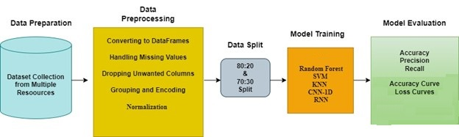
Figure 1 Proposed Methodology for Crime Data Analysis

Dataset Detail
This research uses a large dataset to analyze as well as to predict the crime trends in UK. The dataset which is in CSV format, contains detailed crime records of occurrences from UK Police Data. It includes stop-and-search activities, particularly in determining crime trends. Geographic data, in the shapefile format, enables mapping occurrences across areas to perform analysis of crime distribution. For incorporating demographic data, population data which is utilized from the Wikipedia, utilizing list of English district population were also used.
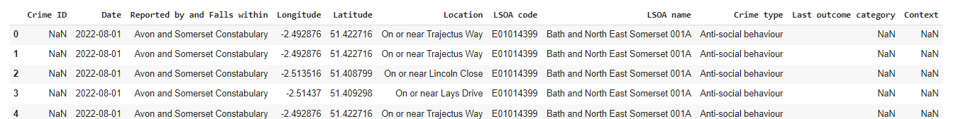
Figure 2: Crime Dataset Detail

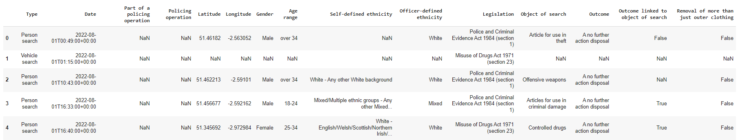
Figure 3: Dataset for Stop & Search
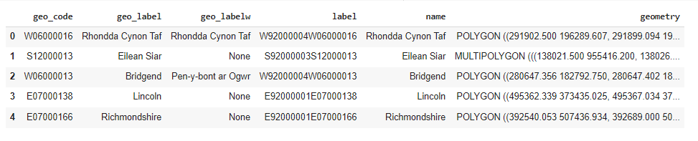
Figure 4: District Dataset

Preprocessing of Data
Data preprocessing is necessary step that involves the cleaning, integration, and preparation of data. Preprocessing was done using following steps:

Dropping Irrelevant Columns and Missing Values
Dropping Columns: Three columns, namely Last Outcome Category, Crime ID, and the Context are dropped as they are irrelevant to the analysis. Removing these columns helps refine the dataset, ensuring a focus on more meaningful features. Rows containing missing values are removed using the dropna() function, which eliminates any incomplete entries from Data_crime, ensuring a dataset with only complete cases.

Groups of Crime_Data by District
The data is further aggregated based on the District column by calculating the number of crimes in each district. The count of crimes for each district is computed and stored in a newly created column named Crime Count, providing a summarized view of crime distribution across districts.

Conversion of Longitude and Latitude for Handling the Missing Values
Missing values in the Longitude and Latitude columns are handled by precomputing the mean coordinates for each district. In cases of invalid or missing coordinates, these precomputed mean values are used for imputation. The results are stored in the long_lat_Data DataFrame, ensuring geographical consistency in the dataset.

Merging Crime Counts and Geospatial Data
The Crime Count data is merged with the averaged coordinates into a single DataFrame based on the District column, ensuring a unified dataset for analysis. To maintain consistency, district names are cleaned by stripping leading and trailing whitespace.

Renaming Districts to Match Shapefile Names
District names in the Data_District DataFrame are converted to lowercase to maintain consistency. Additionally, certain district names are standardized to align with the naming conventions.

Combining Rows for Certain Districts
The rows for City of London and Westminster are merged into a single record to simplify analysis. The combined record retains the sum of the crime counts from both districts, while the latitude and longitude values are averaged to maintain accurate geographic representation.

Stop and Search Dataset Preprocessing
The Stop and Search dataset is examined to assess the presence of missing values, with the percentage of missing data calculated for each column. To refine the dataset, columns such as Policing Operation, Outcome Linked to Object of Search, and Removal of More Than Just Outer Clothing are dropped, as they are not relevant to the analysis. Additionally, any columns with more than 50% missing values are removed to maintain data quality and improve the reliability of subsequent analyses. Stop-and-search outcomes are categorized into severity levels—low, mid, and high—to facilitate analysis. The original Outcome column is dropped after mapping the values to these categories. Additionally, rows with missing severity classifications are removed to ensure data consistency and completeness.

Preparing Shapefile Data
The name column in the shapefile is renamed to District to ensure consistency with the crime dataset. Unnecessary columns are removed, and district names are converted to lowercase to maintain uniform formatting across datasets, facilitating seamless integration and analysis.

Data Frames Conversion
All the data from all of the sources were initially converted into DataFrames to enable proper manipulation and analysis. Crime incidents, geographical data, demographic data, income data, and population data were arranged in tabular form systematically so that they were consistent and easy to handle for further analysis.

Missing Values Handling
Missing values in every DataFrame were identified and handled by suitable treatment measures. According to data nature, missing values were imputed by statistical methods or deleted to ensure data validity and reliability for analysis.

Dropping of the Unwanted Columns
Irrelevant columns such as police id, crime id, and the station id were removed from Dataset.

Encoding and Grouping
The data was classified into significant categories, including geographic areas and the types of crime. The Categorical data was encoded in one-hot encoding. Every data set was preprocessed separately prior to being merged into one single, cohesive DataFrame. The merged data merged crime data with geographic, demographic, and socio-economic data to offer an integrated platform for crime pattern analysis.

Normalization and Cleaning
The merged dataset was normalized to ensure consistency across different data ranges. Any NaN values and the empty cells were removed to maintain data integrity, resulting in a clean and complete dataset ready for further processing and model development.

Visualization Preparation
The cleaned and merged dataset was then utilized to produce a series of various visualizations that explored crime trends on various axes. These included crime distribution across districts, crime to gender ratios, and other trends that were identified. These early findings provided an initial view into the data and revealed patterns that could be drilled down upon utilizing more sophisticated analytics.

EDA (Exploratory Data Analysis)
This section presents the Exploratory Data Analysis (EDA) of the crime data set in the identification of patterns, trends, and correlations that serve as the foundation for further analysis. The Figure illustrates the distribution of different types of crime in the dataset. Of these, "Violence and sexual offences" are the most frequent ones that are reported, followed by "Anti-social behaviour," with "Public order" offences in the third position in frequency. The frequency of these types of crime draws attention to the priority areas of law enforcement and policy interventions because they are frequent threats to public security.
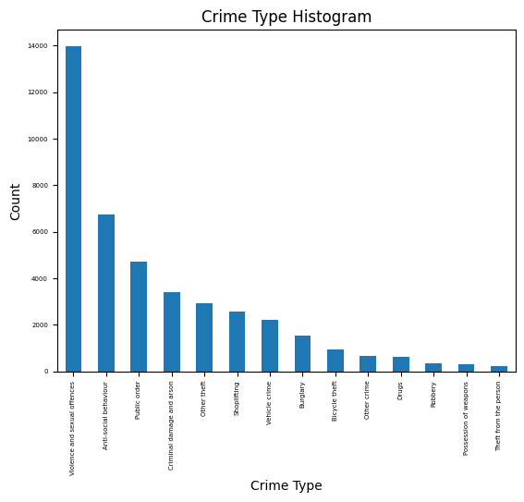
Figure 17 Crime Type Histogram
The graph below is the plot of all categories of crime against time, with each band representing a particular type of crime. The width of band represents higher the number. The graph indicates that similar are "Violence and sexual offenses" ,"Anti-social behavior” rest of the groupings register a slight decline over the given phase. This confirms the overall downward trend in criminality.
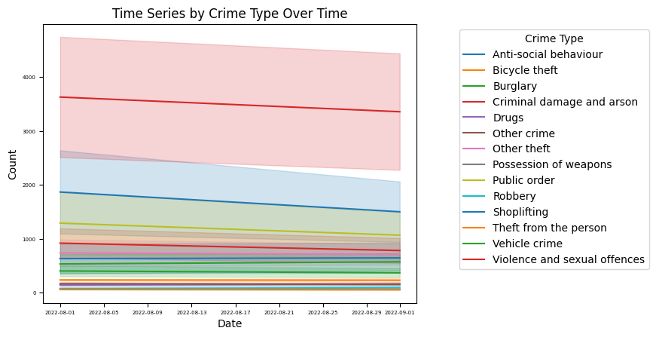
Figure 18 Time Series by the Crime Type Over the period of Time
The figure shows total count of leading categories of crime through time with a stacked area plot. Every color is used for a specific crime type, and the area represents the overall count of crime. While there is a general fall in crime, the relative proportion of different crime types is quite stable. "Violence and sexual offenses" and "Anti-social behavior" are frequent types of categories, with "Public order" ,"Criminal damage and arson," , "Other theft" being next. This constancy suggests that while crime levels are decreasing, the nature of offenses does not vary significantly.
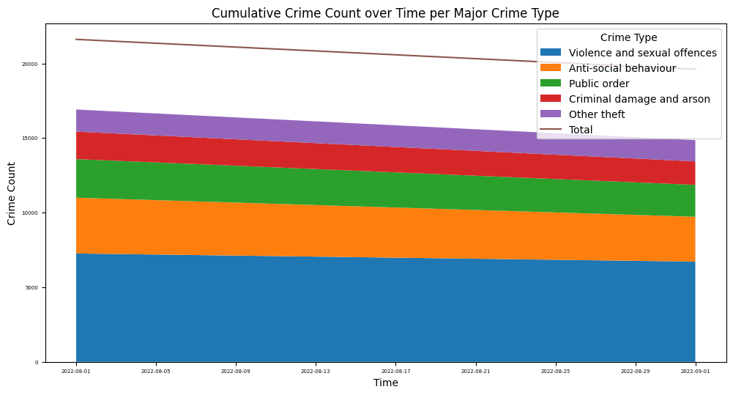
Figure 19 Crime Count Over per Major Crime Type
This map contains a density plot for the purpose of determining where most clustered severe crime is located geographically. Darker indicates more crime density and thus marks the main hotspots. The distribution being bimodal means severe crimes are densely concentrated in two areas, and these could be city areas or regions.
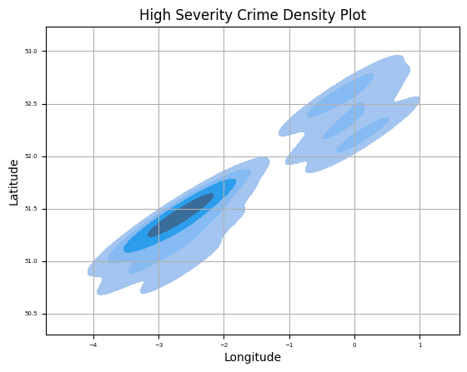
Figure 20: High Severity Density Plot

Data Split
After preprocessing and EDA, the data was divided in training and test sets to evaluate the performance of machine learning and deep learning models. For machine learning models, a 70:30 split was employed, where 70% of data was utilized for training and 30% for testing. The size of this test set provides a better estimate of the model's generalization performance.
Deep learning models were also trained with the same 70:30 split. Because of the computational nature of deep learning models, training was longer and more resource-intensive. To make a trade-off between performance and computational resources, the number of epochs was capped at 20, giving a trade-off between efficient learning and available resources.

Model Selection and Training
After the preprocessing and dataset split, different ML and DL models were used to forecast the trend of crime in the UK city.

Random Forest
Random Forest is an ensemble learning where in it builds multiple Decision trees during training and it takes the mode (or mean for regression tasks) of the individual trees and makes the final decision. This model complemented data analysis of such kind of data given the complex and non-linear dependences between variables. During the training, the most critical hyperparameters like the number of estimators (trees) and the depth of the tree were tuned using cross-validation techniques. Random Forest was one of the leading models for crime pattern modeling, particularly for modeling intricate interactions between demographic and geographic variables, since it has the ability to prevent overfitting and remain robust against noisy data.

SVM (Support Vector Machine)
It is popular technique employed in training machine learning models, with 70:30 most common ratios. Support Vector Machines (SVM) determines the optimal hyperplane that separates various classes in feature space. Since crime data are non-linearly separable, SVM employs kernel tricks to transform the input data to a higher-dimensional space where linear separability can be achieved.
To prevent overfitting, selecting the appropriate kernel linear, polynomial, or radial basis function (RBF), and tuning the regularization parameter 'C' was essential. These parameters control trade-off in maximizing the margin and minimizing the classification errors. SVMs are best suited for dealing with high-dimensional spaces and perform best in applications such as text classification with good overfitting resistance.

KNN (K-Nearest Neighbors)
The k-Nearest Neighbors (KNN) algorithm was used with a 70:30 train-test split. KNN is an nonparametric learning algorithm that classifies instances based on their proximity with nearby instances in the training set. It is a very popular algorithm because of the reason that it is a very simple algorithm, but its performance greatly depends on the selection of the hyperparameter 'K' that determines how many neighbors are to be taken into account. In order to prevent overfitting or underfitting and obtain the best performance, the value of 'K' was optimized using cross-validation. KNN was found to be very effective in detecting similar crime patterns by leveraging proximity relationships in the dataset. KNN uses distance-based similarity, however, it is sensitive to variations in feature scaling, therefore proper normalization in preprocessing is a necessary step to make correct predictions.

CNN-1D (Convolutional Neural Network)
To analyze sequential patterns from the crime dataset, (CNN-1D) was applied. Training was standard with 70:30 data split. CNN-1D is best to learn spatial hierarchies from data by convolving convolutional filters over input sequences to extract salient patterns. The model architecture consists of some convolutional layers followed by corresponding pooling layers compressing the dimension and preserve the significant features. Final layers were fully connected, reducing the learned patterns to predictions. Training was performed for 20 epochs with optimization techniques e.g adaptive learning rates(ADL) and Adam for maximum convergence. This was of particular use in temporal crime pattern identification, allowing more detailed analysis of how criminal patterns evolve with time and geographically.

RNN (Recurrent Neural Network)
To effectively model sequential crime data, RNN was trained on a standard 70:30 split for deep learning. RNNs are especially used for time-series data because they can learn temporal dependencies by maintaining a hidden state that retains information from past inputs. A multi-layered RNN with Long Short-Term Memory (LSTM) units was used in this research to address the vanishing gradient problem that is characteristic of standard RNNs. The model was trained for over 20 epochs, with dropout regularization, gradient clipping applied for stable learning. The approach was very effective in learning intricate temporal patterns in crime data, enabling accurate predictions of future criminal activity based on past trends.

Evaluation Metrics for Machine Learning Models
The ML models were evaluated using the following evaluation metrics:

Precision
Precision is the ratio of true positives to positive model predictions. Precision is determined by dividing TP by TP plus FP. The greater the precision, the smaller the FP, and the better the model in predicting the correct positive cases.

Recall
Recall, or Sensitivity, or True Positive Rate, is a measure of a model's ability to detect true positive instances. The measure is calculated by dividing true positives (TP) by true positives and false negatives (FN). Increasing the recall value implies more actual positive instances correctly detected by the model and fewer cases going undetected

F1-Score
The F1-score provides an even perspective of precision and recall by calculating their harmonic mean. This measure is particularly useful in addressing class imbalance since it considers both false negatives and false positives. The greater the F1-score, the better the overall model performance is in correctly identifying positive cases.

Accuracy
Accuracy is the number of correctly predicted cases, i.e., true positives and true negatives, divided by the number of total predictions. It is correct predictions made out of all predictions. Good accuracy means that the model is performing well overall but may not represent the true model performance if classes are unbalanced.

Evaluation Metrics for Deep Learning (DL) Models
The evaluation metrics used for the models is as below:

Loss Curve Graph
It graphically plots the variation of value of loss function against training epochs, providing learning and model convergence insights. A decreasing loss curve represents a good sign of minimization of the loss function, and it is a sign of improved predictive accuracy. A flat or increasing loss curve, however, may be a sign of issues such as overfitting or undertraining.

Accuracy Curve Graph
The Accuracy Curve graphs the improvement of accuracy against epochs, as a percentage of correct predictions while training. An increasing accuracy curve that keeps on increasing is a sign of good learning and generalization, while flatness or decrease may be a sign of model or training process issues.

Summary
This research offers a framework to analyze and predict patterns of crime throughout the UK based datasets. In collecting data from sources such as Police Data, shapefiles of geography, Wikipedia demographic data, income data from National Statistics, and other population data were gathered. The datasets were imported as data frames and preprocessed with a full preprocessing pipeline to deal with missing values, remove duplicate columns, encode category data, and merge them together into a full analytical dataset. Normalization and data visualization were done to plot the distribution of crime and demographic influence.
Once the data was prepared, it was split into training and testing sets for 70 and 30 for the machine learning and deep learning models. The models employed were Random Forest, Support Vector Machines ,KNN, CNN-1D, RNN. The models were trained for over 20 epochs closely so that they would learn as well as generalize.
The selection of evaluation metrics varied with model type. Machine learning (ML) models were assessed using Recall, Precision, F1-Score, and Accuracy, while deep learning models were assessed using Loss and Accuracy plots. This offers a solid foundation for the analysis of patterns of crime, enabling full model evaluation and offering useful insight for crime prevention and policymaking.

Experimental Results and Analysis
The previous chapters systematically presented groundwork for exploring crime analysis and police deployment optimization in UK. Afterward, we have a comprehensive overview of the collection of datasets, ranging widely from crime reports, stop-and-search, geospatial data, population, and income distribution, all acquired from reliable depositories. Each dataset's significance and how integrating them provides an all-encompassing view of crime-contributing factors is further described.
anticipated these datasets by conceptualizing the preprocessing of data, an unavoidable but also complex process. This included district name normalization across several data sets, handling missing values, and overall data uniformity. Problematic issues such as geographic coordinate inconsistency and data format inconsistency were handled with carefulness to achieve a clean and reliable dataset to analyze.
After dataset preprocessing, set of machine and deep learning algorithms, from RF to CNN, SVM, KNN, RNN were used with unique capability in pattern detection, spatial and temporal trend analysis, and forecasting of crime occurrence. This segment compares the models' performance in terms of an array of measures, evaluating their accuracy, precision, and general performance. Having determined the strongest approaches, the results provide high-quality insights which can be used to improve crime prevention procedures.
Cleaned and Consolidated Dataset: One of the preprocessing steps was normalizing district names to be consistent across all datasets. Apart from that, various data sources such as crime data, stop-and-search data, income data, and population data were combined to generate one single dataset to be analyzed holistically. Another important process was geospatial accuracy. For this, the longitude and latitude values of every district were collected with extreme care and refined, removing differences and inconsistencies. This was necessary to preserve accurate geographic representations, which are of paramount importance for spatial analysis and crime pattern identification.

Experimental Analysis of RF (Random Forest)
The overall accuracy of the Random Forest model is 0.78. Precision, recall, and F1-score of each class are as given below as well as shown in table 2:
A no further action disposal has precision = 0.84, recall = 0.90, and F1-score = 0.87. Khat or Cannabis warning has precision = 0.69, recall = 0.62, and F1-score = 0.65. Arrest has precision = 1.00, recall = 0.83, and F1-score = 0.91. Community resolution has precision = 0.74, recall = 0.57, and F1-score = 0.64. Summons / charged by post has precision = 0.53, recall = 0.49, and F1-score = 0.51. Caution (simple or conditional) has precision = 0.83, recall = 0.40, and F1-score = 0.54. These are differential measures of the ability of the model to predict different classes.
Table 2 Random Forest Classification Results Report
Model | Precision | Recall | F1-Score | Accuracy
Random Forest |  |  |  | 0.78
A no further action disposal | 0.84 | 0.9 | 0.87
Khat or Cannabis warning | 0.69 | 0.62 | 0.65
Arrest | 1 | 0.83 | 0.91
Community resolution | 0.74 | 0.57 | 0.64
Summons / charged by post | 0.53 | 0.49 | 0.51
Caution (simple or conditional) | 0.83 | 0.4 | 0.54

Experimental Analysis of Support Vector Machine (SVM)
SVM model overall accuracy is 0.63 as shown in table 3. Performance measure for every category is as follows: disposal of no further action has precision of 0.63, recall of 1.00, F1-score of 0.80. Precision, recall, and F1-score are all 0.00 for Khat or Cannabis warning, Arrest, Community resolution, Summons / charged by post, Caution (simple or conditional) respectively, i.e., that the model couldn't classify these into the correct classes. These observations suggest that model predicted one class at cost of others.
Table 3 SVM Comparative analysis of Classification report
Model | Precision | Recall | F1-Score | Accuracy
SVM |  |  |  | 0.63
A no further action disposal | 0.63 | 1 | 0.8
Khat or Cannabis warning | 0 | 0 | 0
Arrest | 0 | 0 | 0
Community resolution | 0 | 0 | 0
Summons / charged by post | 0 | 0 | 0
Caution (simple or conditional) | 0 | 0 | 0

Experimental Analysis of KNN
The overall model performance of KNN model is 0.75 as shown in table 4. A no further action disposal has precision of 0.72, recall of 0.91, and F1-score of 0.84. Khat or Cannabis warning has precision of 0.64, recall of 0.47, and F1-score of 0.54. Arrest has precision of 0.80, recall of 0.21, and F1-score of 0.33. Community resolution has precision of 0.66, recall of 0.48, and F1-score of 0.55. Summons / charged by post has precision of 0.58, recall of 0.43, and F1-score of 0.50. Caution (simple or conditional) has precision of 0.76, recall of 0.35, and F1-score of 0.48. These are the results indicating various classification performance for various outcome categories.
Table 4 KNN Comparative analysis of Classification report
Model | Precision | Recall | F1-Score | Accuracy
KNN |  |  |  | 0.75
A no further action disposal | 0.72 | 0.91 | 0.84
Khat or Cannabis warning | 0.64 | 0.47 | 0.54
Arrest | 0.8 | 0.21 | 0.33
Community resolution | 0.66 | 0.48 | 0.55
Summons / charged by post | 0.58 | 0.43 | 0.5
Caution (simple or conditional) | 0.76 | 0.35 | 0.48

Summary
Figure 21 is a bar plot illustrating the accuracy of Random Forest, SVM, and KNN. Figure 22 is an overall comparison of the models based on Precision, Recall, and F1-score. In all aspects of performance, Random Forest performed better than both KNN and SVM, which confirms it to be the strongest and most efficient model on this dataset. KNN was reasonably good in comparison to both the above-mentioned models, especially precision-wise, but SVM was poor with low precision and recall, which resulted in it having poor F1-score. RF was the best-performing model, and SVM was least efficient one.
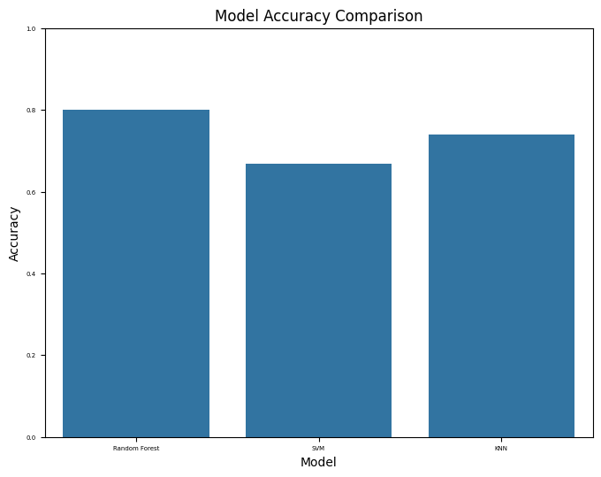
Figure 21 Models Accuracy Comparison
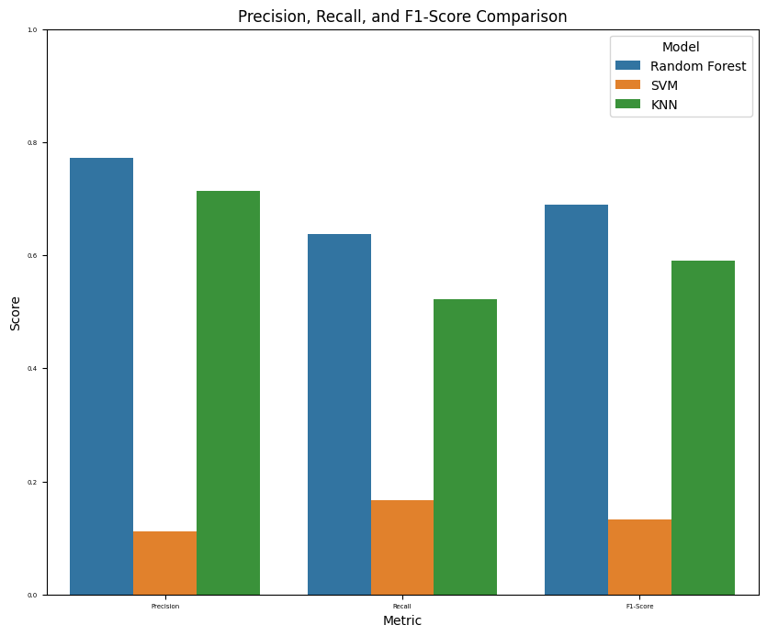
Figure 22 Models Scores Comparison

Experimental Analysis of CNN-1D
Overall accuracy of the CNN model is 0.64. Class-wise performance measures state that A no further action disposal has precision of 0.64, recall of 0.99, and F1-score of 0.78, i.e., most of the instances of this class are correctly classified. Khat or Cannabis warning has precision of 0.62, recall of 0.05, and F1-score of 0.10, i.e., some of the predictions are correct but most of the actual cases are not detected. For Arrest, Community resolution, Summons / charged by post, and Caution (simple or conditional), the model has precision, recall, and F1-score of 0.00, i.e., the model classifies these classes not at all.
Macro average scores (precision: 0.21, recall: 0.17, F1-score: 0.15) reflect poor performance for all classes, assigning equal importance to all classes. Weighted average scores (precision: 0.55, recall: 0.64, F1-score: 0.52) reflect that the model is doing good for frequent classes but bad for rare classes.
Table 5 CNN Comparative analysis of Classification report
Class | Precision | Recall | F1-Score
A no further action disposal | 0.64 | 0.99 | 0.78
Khat or Cannabis warning | 0.62 | 0.05 | 0.10
Arrest | 0.00 | 0.00 | 0.00
Community resolution | 0.00 | 0.00 | 0.00
Summons / charged by post | 0.00 | 0.00 | 0.00
Caution (simple or conditional) | 0.00 | 0.00 | 0.00
Accuracy |  |  | 0.64
Macro Avg | 0.21 | 0.17 | 0.15
Weighted Avg | 0.55 | 0.64 | 0.52

The plots in figure 23 indicate the training curve of a CNN model for 100 epochs, tracking accuracy and loss for training and validation sets. The training accuracy rises steadily, to around 0.665, while the validation accuracy oscillates at around 0.64, indicating slight instability. This indicates that although the model is learning from the training data, its generalization to unseen validation data is poor.
The loss plots indicate a steady decline, with training loss declining steadily, indicating proper learning. The validation loss is higher and declines at a slower rate, indicating that the model can be challenged with generalization. The difference between training and validation performance indicates potential underfitting or dataset imbalance. Additional improvements, such as hyperparameter tuning, data augmentation, or regularization methods, may be necessary to allow the model's performance and minimize validation oscillations.

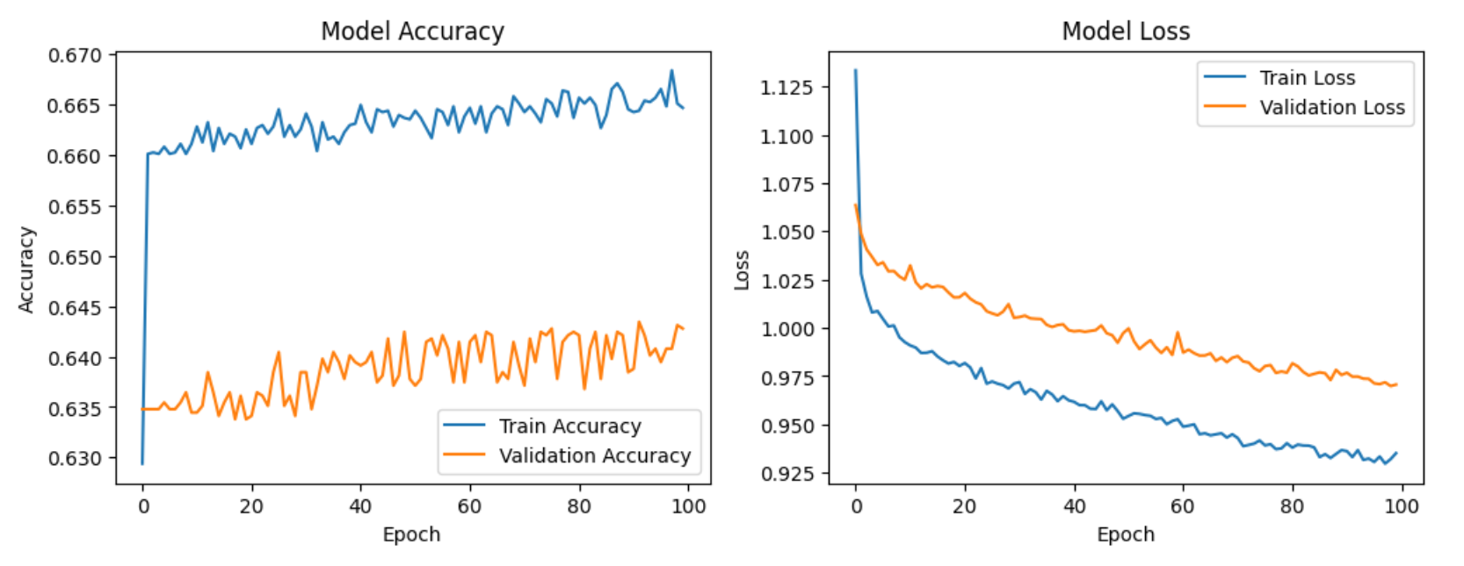
Figure 23 CNN Accuracy & Loss Plots

Experimental Analysis of RNN
The RNN model had Accuracy of 0.73. A no further action disposal class had highest recall (0.95) and F1-score (0.83), both reflecting high detection. Arrest was accurately classified with high precision (0.92), but its recall (0.63) reflects it failed to catch some cases. Classes like Summons / charged by post and Caution (simple or conditional) had low recall (0.25 and 0.29, respectively), which reflects it is difficult to detect all cases. Macro average recall (0.48) reflects the difficulty of detecting all classes equally, and the weighted F1-score (0.70) reflects the model performs well but can perform better with improved recall on minority classes.
Table 6 RNN Comparative analysis of Classification report
Class | Precision | Recall | F1-Score
A no further action disposal | 0.74 | 0.95 | 0.83
Khat or Cannabis warning | 0.70 | 0.35 | 0.46
Arrest | 0.92 | 0.63 | 0.75
Community resolution | 0.60 | 0.39 | 0.47
Summons / charged by post | 0.64 | 0.25 | 0.36
Caution (simple or conditional) | 0.95 | 0.29 | 0.44
Accuracy |  |  | 0.73
Macro Avg | 0.76 | 0.48 | 0.55
Weighted Avg | 0.72 | 0.73 | 0.70

The training plots of the RNN as shown in figure 24 show the model's learning curve over 100 epochs, and trends in the training and validation set accuracy and loss. Training accuracy in the accuracy plot raises steadily to a value of around 0.73, i.e., the model is picking up patterns of the training set very well. The validation accuracy is lower and fluctuates through the training session. The variance in training and validation accuracy highlights that the model may be memorizing training examples rather than extracting generalizable features.
The loss plot shows decreasing training and validation loss steadily, i.e., the RNN model is optimizing parameters sufficiently. The validation loss, though, remains still higher than training loss, once again indicating the possibility of overfitting.

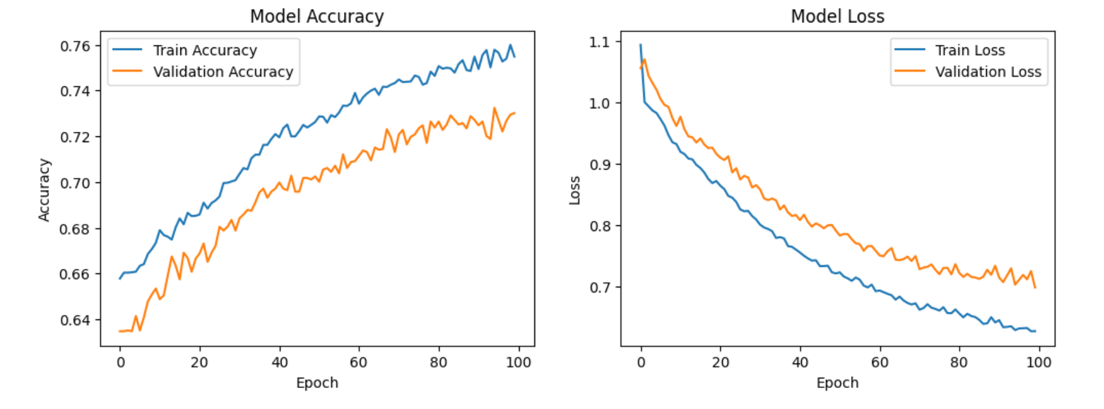
Figure 24 RNN Accuracy & Loss Plots

Overall Performance Analysis
The overall model comparison shows extreme variation in their performance in classifying different categories of classes. Random Forest performed best with a 0.78 accuracy, showing well-balanced performance on all classes. It showed high precision, recall, and F1-scores, especially with high performance on A no further action disposal instances and Arrest instances, and relatively good performance for other classes. KNN had an accuracy of 0.75, and it performed relatively well, especially in A no further action disposal, but poorly with low recall in some classes like Arrest and Summons/charged by post, showing low ability to identify these cases correctly. RNN, with an accuracy of 0.73%, showed strong recall on dominant classes but low ability to generalize across all classes, with classes like Summons/charged by post and Caution (simple or conditional) being more difficult to classify. CNN-1D and SVM both performed at 0.64 accuracy, but CNN-1D performed well with the dominant classes and poorly with the underrepresented classes. SVM, however, mostly did not classify anything but A no further action disposal, showing extreme class imbalance problems in classification. The training graphs of the RNN and CNN-1D also show that although the models learned, their validation accuracy fluctuated, showing generalization problems. The loss curves also show that although the deep learning models showed constant optimization, there was increased validation loss, which may show class imbalance or overfitting problems. Consequently, RF performed well, while SVM was worst, and the deep learning models (CNN-1D and RNN) performed well but had class imbalances, showing the need for further optimization factors like hyperparameter tuning and data augmentation.

Conclusion and Future Work

Conclusion
In this research examined crime patterns in the UK by integrating various datasets using predictive models to obtain insightful information. By ensuring appropriate preprocessing and analysis of the data, a deeper understanding of the distribution of crimes and its determinants was achieved. Exploratory data analysis revealed strong correlation between crime activity and demographic and socio-economic determinants. Integration of crime data with income level and population density revealed a deeper insight into how crime rates change depending on economic and geographical backgrounds.
Performance in the application of various predictive models revealed that Random Forest performed better, with a performance of 78% when predicting crime types. Though it performed excellently in determining the most common crime types, performance was poor with less common crime types. The performance of the SVM model was extremely poor, while KNN yielded less frequent but better predictions. CNN and RNN, were good but plagued by issues of overfitting, which led to their loss of generalizability.
Robust performance in the Random Forest model reveals its efficacy in classifying crime since it was able to cope with the various sources of data and yield reliable predictions. Though deep learning models are promising, they need to be improved to address issues of overfitting and enhance prediction reliability. The findings emphasize the need to continually optimize predictive model techniques.
In practice, this study has clear policy and law enforcement implications for crime prevention. With the predictive capability of the Random Forest model, policymakers can deploy resources in the most optimal manner and create effective and targeted crime prevention policies. Socio-economic determinants of crime can also be used to aid in the design of more effective and integrated intervention policies. This thesis has explored alternative modeling paradigms for crime analysis and offered valuable insights into crime patterns. Future research should focus on creating more sophisticated deep learning models and larger data sets to further improve predictive power and generalizability.

Limitations
This study has a number of limitations that needs attention. It contained small number of datasets, i.e., crime incidences, income levels and population, that did not seizure the heterogeneity and diversity at different locations. Manual extraction of district-wise data is susceptible to inconsistencies and inaccuracies, which can influence the robustness of findings. Secondly, even though the Random Forest model was robust, SVM and deep learning-based models were confronted with substantial challenges, e.g., overfitting and poor accuracy for less common crime classes. Class imbalance in the dataset also influenced the performance of the models, particularly in the detection of rare types of crime, leading to biased findings. These limitations point towards the need for more robust datasets, sophisticated data preprocessing techniques, and model tuning for better predictive accuracy and generalizability in future studies.

Future Work
Future research can expand on the present study by utilizing more data sources to strengthen and improve predictive models. Adding more crime types, socio-economic factors, and real-time data may provide a better insight into crime patterns and the determinants thereof.
Additionally, deep learning models must be developed further to minimize overfitting and improve generalization. The use of advanced regularization methods, data augmentation, and hybrid modeling paradigms may lead to better predictive performance. In addition, the integration of response from law execution agencies and the use of real time data may improve the practicality of these approaches, thus enabling actionable insights into crime prevention planning and resource allocation.

References

Ateş, E.C., Bostancı, G.E. and Msg, S., 2020. Big data, data mining, machine learning, and deep learning concepts in crime data. Journal of Penal Law and Criminology, 8(2), pp.293-319.

Ahmed, S., Gentili, M., Sierra-Sosa, D. and Elmaghraby, A.S., 2022. Multi-layer data integration technique for combining heterogeneous crime data. Information Processing & Management, 59(3), p.102879.

Elgar, E., 2010. Handbook on the Economics of Crime.

AHISHAKIYE, E., TAREMWA, D., OMULO, E. O. & NIYONZIMA, I. 2017. Crime prediction using decision tree (J48) classification algorithm. International Journal of Computer and Information Technology, 6, 188-195.

Bharath, R.R., Sulthan, H.K, Mingaz, R.M. and Kumaravengatesh, S.N, A MACHINE LEARNING APPROACH TO CRIME ANALYSIS AND FORECASTING FOR PREDICTION & PREVENTION.

BRAGA, A. A. & WEISBURD, D. 2010. Policing problem places: Crime hot spots and effective prevention, Oxford University Press.

Curry, G.D., Ball, R.A., Fox, R.J. and Fox, R.J, 1994. Gang crime and law enforcement record keeping. US Department of Justice,Office of Justice Programs,National Institute of Justice.

BENNELL, C., JONES, N. J. & MELNYK, T. 2009. Addressing problems with traditional crime linking methods using receiver operating characteristic analysis. Legal and Criminological Psychology, 14, 293-310.

BERNASCO, W. & ELFFERS, H. 2010. Statistical analysis of spatial crime data. Handbook of quantitative criminology, 699-724.

BROOKES, A. C. 2017. Police self-deployment at critical incidents: a wicked problem or a part of the solution? , Monterey, California: Naval Postgraduate School.

DAU, P. M., VANDEVIVER, C., DEWINTER, M., WITLOX, F. & VANDER BEKEN, T. 2020. What do we really know about police patrol? A systematic review of routine police patrol research. SOCARXIV.

CAMACHO-COLLADOS, M. & LIBERATORE, F. 2015. A decision support system for predictive police patrolling. Decision support systems, 75, 25-37.

CHOW, A. H., CHEUNG, C. & YOON, H. 2015. Optimization of police facility locationing. Transportation research record, 2528, 60-68.

DRAWVE, G., GRUBB, J., STEINMAN, H. & BELONGIE, M. 2019. Enhancing data-driven law enforcement efforts: exploring how risk terrain modeling and conjunctive analysis fit in a crime and traffic safety framework. American journal of criminal justice, 44, 106-124.

Eck, J.E., 2017. Regulation to prevent crime. In Handbook of crime prevention and community safety (pp. 294-316). Routledge.

DEUCHAR, R., CRICHLOW, V. J. & FALLIK, S. W. 2021. Reactive Policing of Gangs: Cops as “Warriors”. Police–Community Relations in Times of Crisis. Bristol University Press.

Farmer, D.J.1982. Police resources, Toward a theory of Police Study. Int'l Rev. Police Dev., 5, p.34.

Chase, J., Du, J., Fu, N., Le, T.V. and Lau, H.C., 2017, November. Law enforcement resource optimization with response time guarantees. In 2017 IEEE Symposium Series on Computational Intelligence (SSCI) (pp. 1-7). IEEE.

Du, Y. and Ding, N., 2023. A systematic review of multi-scale spatio-temporal crime prediction methods. ISPRS International Journal of Geo-Information, 12(6), p.209.

GURR, T. R. 1981. Historical trends in violent crime: A critical review of the evidence. Crime and justice, 3, 295-353.

Ghosh, D., Chun, S.A., Shafiq, B. and Adam, N.R., 2016, June. Big data-based smart city platform: Real-time crime analysis. In Proceedings of the 17th International Digital Government Research Conference on digital government research (pp. 58-66).

HAJELA, G., CHAWLA, M. & RASOOL, A. 2020. A clustering based hotspot identification approach for crime prediction. Procedia Computer Science, 167, 1462-1470.

BHUYAN, H. K. & PANI, S. K. 2021. Crime predictive model using big data analytics. Intelligent Data Analytics for Terror Threat Prediction: Architectures, Methodologies, Techniques and Applications, 57-78.

Gahalot, A., Dhiman, S. and Chouhan, L., 2020, February. Crime prediction and analysis. In 2nd International Conference on Data, Engineering and Applications (IDEA) (pp. 1-6). IEEE.

JOHNSON, S. D. 2010. A brief history of the analysis of crime concentration. European Journal of Applied Mathematics, 21, 349-370.

Hart, T.C, 2020. Hot spots of crime, Methods and predictive analytics. Geographies of Behavioural Health, and Disorder. "The Intersection of Social Problems and Place", pp.87-103.

KSHATRI, S. S., SINGH, D., NARAIN, B., BHATIA, S., QUASIM, M. T. & SINHA, G. R. 2021. An empirical analysis of machine learning algorithms for crime prediction using stacked generalization: an ensemble approach. Ieee Access, 9, 67488-67500.

Levine, M.J. and McEwen, J.T., 1985. Patrol deployment. US Department of Justice, National Institute of Justice, Office of Communication and Research Utilization.

LEONG, K. & SUNG, A. 2015. A review of spatio-temporal pattern analysis approaches on crime analysis. International E-Journal of Criminal Sciences.

Matereke, T., Nyirenda, C.N. and Ghaziasgar, M., 2021, September. A comparative evaluation of spatio temporal deep learning techniques for crime prediction. In 2021 IEEE AFRICON (pp. 1-6). IEEE.

MANDALAPU, V., ELLURI, L., VYAS, P. & ROY, N. 2023. Crime prediction using machine learning and deep learning: A systematic review and future directions. IEEE Access, 11, 60153-60170.

Mukhopadhyay, A., Zhang, C, Vorobeychik, Y., Tambe, M., Pence, K. and Speer, P., 2016. Optimal allocation of police patrol resources using a continuous-time crime model. In Decision and Game Theory for Security: 7th International Conference, GameSec 2016, New York, NY, USA, November 2-4, 2016, Proceedings 7 (pp. 139-158). Springer International Publishing.

PRAMANIK, M. I., LAU, R. Y., YUE, W. T., YE, Y. & LI, C. 2017. Big data analytics for security and criminal investigations. Wiley interdisciplinary reviews: data mining and knowledge discovery, 7, e1208.

Lind, R.C. and Lipsky, J.P., 1971. The measurement of police output: conceptual issues and alternative approaches. Law & Contemp. Probs., 36, p.566.

PITT, M. 2010. Identifying a Predictable Property Crime Trend Model in the North East of England. Durham University.

Raisinghani, M., Sawra, R., Dhavalikar, O., Chhabria, P. and Giri, N., 2022, April. Crime Analysis Using Artificial Intelligence. In Edge Analytics: Select Proceedings of 26th International Conference—ADCOM 2020 (pp. 33-42). Singapore: Springer Singapore.

QASIM GANDAPUR, M. & VERDÚ, E. 2023. ConvGRU-CNN: Spatiotemporal deep learning for real-world anomaly detection in video surveillance system.

Shafique, I., Zahra, S.A., Farid, T. and Sharif, M., 2017. Role of GIS in crime mapping & analysis. Sukkur IBA Journal of Computing and Mathematical Sciences, 1(2), pp.39-47.

SAFAT, W., ASGHAR, S. & GILLANI, S. A. 2021. Empirical analysis for crime prediction and forecasting using machine learning and deep learning techniques. IEEE access, 9, 70080-70094.

Rani, A. and Rajasree, S., 2014. Crime trend analysis and prediction using mahanolobis distance and dynamic time warping technique. Int J Comput Sci Inf Technol, 5(3), pp.4131-4135.

Smith, R., Graettinger, A.J., Keith, K., Hudnall, M. and Parrish, A., 2005. Using GIS for law enforcement. Journal of safety research, 36(5), pp.477-479.

Tamir, A., Watson, E., Willett, B., Hasan, Q. and Yuan, J.S., 2021. Crime prediction and forecasting using machine learning algorithms. International Journal of Computer Science and Information Technologies, 12(2), pp.26-33.

STEC, A. & KLABJAN, D. 2018. Forecasting crime with deep learning. arXiv preprint arXiv:1806.01486.

VAN WILSEM, J., WITTEBROOD, K. & DE GRAAF, N. D. 2006. Socioeconomic dynamics of neighborhoods and the risk of crime victimization: A multilevel study of improving, declining, and stable areas in the Netherlands. Social Problems, 53, 226-247.

TP, 2022. Crime Prediction with Geo Hotspots and Heatmaps using Machine Learning. Special Education, 2(43).

Silva Atencio, Umana Ramírez and M. 2023. Predictive models in pandemic times and their impact on the analysis of crime. Journal of applied research and technology(JART), 21(3), pp.484-495.

WANG, D., DING, W., LO, H., STEPINSKI, T., SALAZAR, J. & MORABITO, M. 2013. Crime hotspot mapping using the crime related factors—a spatial data mining approach. Applied intelligence, 39, 772-781.

Verma, N. and Dombrowski, L., 2018, April. Confronting social criticisms: Challenges when adopting data-driven policing strategies. In Proceedings of the 2018 CHI Conference on Human Factors in Computing Systems (pp. 1-13).

ZHANG, Y., SIRIARAYA, P., KAWAI, Y. & JATOWT, A. 2020. Predicting time and location of future crimes with recommendation methods. Knowledge-Based Systems, 210, 106503.

YADAV, R. & SHEORAN, S. K. Crime prediction using auto regression techniques for time series data. 2018 3rd international conference and workshops on recent advances and innovations in engineering (ICRAIE), 2018. IEEE, 1-5.

WANG, F. 2005. Geographic information systems and crime analysis, IGI Global.

Appendix A 